**Effects of Shelter Canopy on Microclimate in Arid and Semi-Arid regions: A Potential Tool for Conservation.**

Nargol Ghazian1*, Mario Zuliani1, Michael Westphal2, and Christopher J. Lortie1, 3.

1Department of Biological Science, York University, 4700 Keele St, Toronto, ON M3J 1P3, Canada

2US Bureau of Land Management, Central Coast Field Office, 940 2nd Ave, Marina, CA 93933, United States

3National Centre for Ecological Analysis and Synthesis (NCEAS), 735 State St #300, Santa Barbara, CA 93101, United States

*Corresponding Author: Department of Biological Science, York University, 4700 Keele St, Toronto, ON, M3J 1P3, Canada. Email: [nargolg1@my.yorku.ca](mailto:nargolg1@my.yorku.ca)

**Abstract**

Anthropogenic factors such as climate change, land use, urbanization, alongside the spread of invasive species are some of the challenges impacting the arid and semi-arid regions of the western United States. Climate change in particular negatively impacts wildfire regimes and in turn increases re-establishment competition between native and invasive vegetation. The canopy of many native vegetation, such as shrubs and trees, not only provides a refuge from predators, but also offers a cool microclimate where animals can rest away from direct sunlight. Because native vegetation canopy, such as those of shrub, may be crucial to the survival of other taxa, it’s vital to find modes of conservation whilst post-disturbance landscape recovery is made. In this study, we aimed to build artificial canopies of two shapes (triangle and rectangle) that were easily assembled and were more-cost-effective than prototypes already discussed in the literature called UV Permeable Shade Cloth Shelters (UPSS). The shelters were built using PVC piping for the skeletal scturecure and shade cloths at 3 light blockage intensities: 15%, 50%, and 90%. Furthermore, we paired temperature and light sensor logger to each open-shelter microsite to test the efficiency of the shelters at cooling and shading during the different time blocks of the day. Shelters offered more stable temperatures and more consistent blockage from sunlight compared to the open. This was particularly true during the afternoon and the evening. Triangle was superior to rectangle and functioned best at 90% blockage. The ‘hole’ pattern on the shade cloths functioned similarly to vegetation branches, resulting in irregularities in incoming sunlight, which may offer beneficial thermal and radiative properties that need to be further explored. The use of these shelters can be incorporated into conservation practices in order to mitigate the impacts of anthropogenic disturbance.

**Introduction**

As the rate of anthropogenic climate change increases, many arid and semi-arid regions in western United States face extensive ecological shifts as a consequence1. At the current rate, approximately 8% of all species worldwide are expected to become extinct2. Factors such as land-use alongside urbanization can further decrease biodiversity by reducing the available terrestrial habitant in which species can live3–5. In deserts, animals will not only experience large scale changes such as draught, but also small scale changes such fluctuations in temperature and light, since for these organisms deserts are extremely heterogeneous at fine scales6,7.

The type of vegetation that covers a terrestrial habitat is an important characteristic that can influence: foraging site selection8, reproduction9, predator-prey interaction10, and thermoregulation11. Many of the above can be classified as a positive interaction between the vegetation and beneficiary species.

The state of California is home to many diverse landscapes, many of which are dominated by a magnificent variety of shrubs12. Species such as *Ephedra californica* (Mormon Tea) are known to be foundational plants, able to provide a variety of benefits to protégé species through various mechanistic pathways that include, but are not limited to, seed trapping, abiotic stress amelioration, and soil modification13. In many arid and semi-arid regions, dominant shrubs are able to positively facilitate other taxa through the shelter effects provided by their canopy14. Canopy microclimates are generally cooler, more humid, and have lower solar radiation compared to open sites14,15. Shrubs fulfil a critical functional role; hence, more species are associated with shrubs than open spaces16. This is evident in many lizards species such as *G. sila* that are found in shrubs in high afternoon temperatures17.

In recent years however, land-use (agriculture, oil fields, urbanization) and the spread of invasive grasses have altered the ecosystem dynamicsof many scrublands18,19. This is unfortunate since post-disturbance recovery of native vegetation can be slow20. Given the current rates and predictor models, it is now more crucial than ever to find ways to mitigate the impacts of climate change. Because shrub canopy may be crucial to the survival of other taxa, it’s therefore important to find alternate modes of conservation whilst landscape recovery is made and new shrubs are grown.

Artificial canopies, such as rainout shelters and Open-Top-Chambers (OTC), have been used to study the change in a variety of abiotic parameters such as CO2, temperature, soil temperature, solar radiation, and humidity 21,22. Although these shelters are effective, they’re relatively expensive to build and may be difficult to assemble in a short period of time. The landscape alongside the climate of southern California provides us with the opportunity to explore the effects man-made shelters that are inexpensive and can easily be assembled in the field. A cheaper alternative that pioneered in this study is UV Permeable Shade Cloth Shelters (UPSS) made with PVC pipe skeleton and shade cloth cover.

This study aims to A) describe the methodology of constructing UPSS, B) explore its effects on canopy microclimate, specifically temperature and light intensity, and C) examine how various light blockage intensities and shelter shape influence the above parameters. Given that man-made structures, as well as natural vegetation have the ability to alter their canopy’s microclimate, it was predicted that the highest blockage intensity would result in the greatest cooling effect and would be the most effective at lowering solar radiation. Furthermore, rectangular shelters would be better at cooling compared to those that are triangular as triangle blocks wind more effectively, leading to air stagnation and an increase in temperature (temperature stagnation)23. These predictions were tested by deploying temperature and light loggers inside and outside of shelters.

**Materials & Methods**

***Study site***

This study was conducted in Panoche Hills Management Area located on the western edge of the San Joaquin Valley, California (Bureau of Land Management; 36◦41.78′ N, 120◦47.89′ W). The region’s climate can be characterized as arid/semi-arid. The average annual precipitation is 25.5 cm with an annual low and high temperature of 10.4 ºC and 76.3 ºC, respectively. Winter and fall are considered to be the wettest seasons. The mean temperature observed in May is 20.4 ºC and 23.7 ºC in June (Los Baños Weather Station, <http://www.usclimatedata.com/>).

The region is heavily dominated by invasive grasses such as: *Bromus madritensis ssp. Rubens, Bromus hordeaceus, Erodium cicutarium* and *Schismus barbatus*. Shrubs are generally evenly distributed on this sea of invasive grasses. The presence of the native community is low and includes: *Phacelia tanacetifolia, Amsinckia grandiflora,* and *Monolopia congdonii.*

***Shelter Construction***

Shelters were constructed using PVC piping and UV permeable shade cloths at three light blockage intensities: 15%, 50%, and 90%. The open (no structure) at 0% light blockage served as control. The cloths were attached to the PVC using zip ties. Table 1 describes the number of pieces at specific dimensions and diameter needed to build each triangle or square shelter. There were six replicates of each shape-two pertaining to each blockage percentage-for a total of 12 replicates. Pipes were slid onto metal stakes, which were hammered into ground for stability (Supplementary Appendix; Figure 1). Latitude and longitude coordinates of each shelter-open pair was also recorded (Table 1; Supplementary Appendix). Rectangular (referred to as square in stats) shelters consisted of two sides with two 61 cm ½ inch pipes facing the ground connected to a 61 cm ¾ inch pipe using a 90º elbow. Triangular shelters were built using a 75 cm ¾ inch top pipe connected to a ½ inch to ¾ inch adapter. The adapter was then attached to a ½ inch 3-way 90º elbow fitted with two 61 cm ½ pipes. Cloths were used to cover two side of the triangular shelters and three sides of the rectangular shelters. Because the terrain was uneven, dimensions very slightly differed between shelters; thus, cloths were not pre-cut and instead cut into the desired shape and size after PVC skeletal structure assembly was done. The directionality of shelters was at random. Shelters were visited on a weekly basis to ensure that they stay intact.

**Table 1.** A list of PVC pieces used for shelter skeleton construction is provided alongside the quantity needed to build one of each shelter-type.

|  |  |  |
| --- | --- | --- |
| Piece | Quantity for Triangular Shelter | Quantity for Rectangular Shelter |
| 61 cm (½ inch diameter) pipe | 4 | 4 |
| 61 cm (¾ inch diameter) pipe | NA | 2 |
| 75 ¾ cm pipe | 1 | NA |
| ½ inch to ¾ inch adapter | 2 | NA |
| ½ inch to ¾ inch 2-way 90º elbow | NA | 4 |
| ½ inch 3-way 90º elbow | 2 | NA |

***Abiotic Measurements***

To measure the difference in light and temperature within shelters and between shelters and open microsites, Onset HOBO Temperature/Light Pendant (8K) loggers were placed inside and directly outside to the right of the shelters. A total of 24 pendants were used, where each pendant was tied to a plastic stake using a zip tie. Stakes were hammered into the ground until stable with ~10 cm remaining above ground. This was to done to ensure that logger data were not influence by ground cover and true ambient conditions both inside and outside were recorded. Air temperature (ºF) and light intensity (lum/ft2) were recorded hourly. Loggers were placed out mid-May (20th) and collected in mid-June (12th), 2019 to represent spring-summer seasonal variation. Data collected were then categorized into time blocks: morning (6 AM-11:59 PM), afternoon (12 PM-11:59 PM), and evening (12:00AM-5:59AM).

***Statistical Analyses***

All statistics were performed using R version 3.6.124. Workflows can be found on: <https://nargolg1.github.io/Animal-Behaviour-and-Climate-project/CH3/shelter-comparison.html>. Temperature and light data distribution were looked at (*ggqqplot* function, *ggplot2*25 library) where temperature followed a positively-skewed, normal distribution and intensity appeared to have an Poisson distribution. All zeros for the intensity parameter were omitted as they corresponded to afternoon/evening when there was naturally total darkness, in order not to interfere with true shelter light blockage analyses. The relationship between temperature and light intensity was examined using Kendall’s rank correlation (non-parametric, continuous data), as well as scatterplots with *Generalized Linear Model (GLM)* fitted regression lines for the different time-blocks and light blockage intensities using the function ggplot from the package *ggplot2*. GLMs were used to compare between temperatures, shape, and cover type with time block serving as a co-variate. This model was fitted with a Gaussian distribution. A similar model was used for intensity with a Poisson fit. GLM dispersion parameters and AIC scores were used to compare and select the appropriate fit. An ANOVA with a Chi-square test was performed where all the variables in the both models were shown to be significant. Subsequently, a post-hoc comparison of the GLMs was performed (function *emmeans*, *emmeans* library)26 to test for specific interactions.

**Results**

The above methods resulted in the construction of the shelters in figures 1. Shelter assembly was uncomplicated and lasted around 15 minutes per shelter when working in pairs. Shelters remained intact during the duration of the entire study period. Zip ties proved to be effective at keeping the shade cloths attached to shelter skeletal structure.

In general, an increase in temperature was associated with an increase in light intensity (Kendall’s tau= 0.487, p <2.2e-16). This was true irrespective of shape, time block, or blockage intensity/cover type (Fig. 3-6 Supplementary Appendix). Shelters significantly altered canopy microclimate during the study period at all times of the day. There were significant differences between the different blockage intensities when predicting temperature (ANOVA F= 5.763, p= 0.016) and light intensity (ANOVA F= 213.68, p<2.2e-16). Differences between rectangle and triangle were particularly important during the evening (p<0.0001), Furthermore, the various structures also affected temperature (ANOV F= 90.484, p<2.2e-16) and light (ANOVA F=37.154, p<2.2e-16) in significantly different ways. Light blockage intensity (cover type), shape, and time block were used as predictors for temperature and light intensity GLM. In the post-hoc analyses, differences between rectangle and triangle showed to be important. Triangle generally shown to be better at cooling during all times of the day; however, this comparison was only significant at 90% blockage (Table 2; p<0.0001). Triangle was also superior to rectangle when it came to lowering the light intensity. At 50% and 90% blockage triangle showed to more effective at controlling incoming light (Table 3; p<0.0001). This was true regardless of the time of the day. However, rectangle was better at reducing incoming light at 15% light blockage (p<0.0001). The 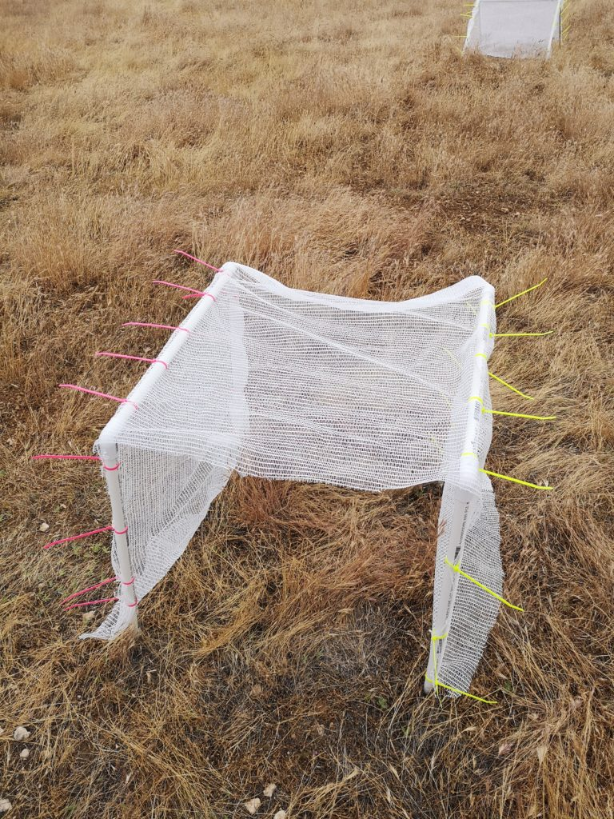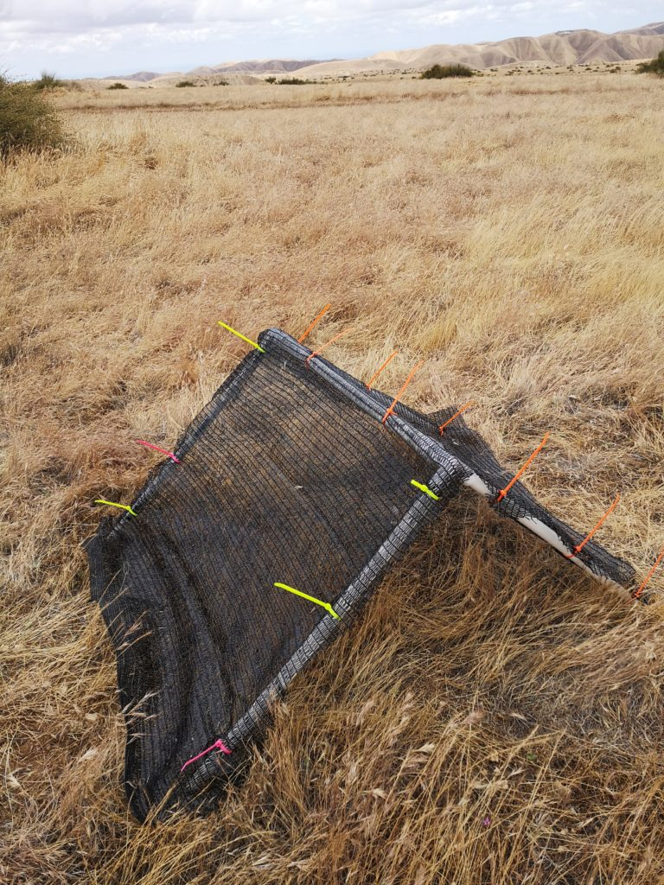open microsite also showed to experience lower sunlight intensity than triangle at all time blocks (p<0.0001).

**Figure 1. Left-Triangular shelter with 90% shade cloth attached to PVC skeleton using zip ties. Right-Rectangular shelter with 15% shade cloth attached to two PVC skeletal frames.**

**Table 2. Emmeans values and standard error for square and triangle shelters are given for the different time blocks of the day at Panoche Hills, CA. Values are for *emmeans* comparison with temperature as the response variable. Values were compared using a pairwise method. Significance is measure at α < 0.05 and bolded if significant. Only significant comparisons were included in the table.**

|  |  |  |  |  |  |
| --- | --- | --- | --- | --- | --- |
| Time Block | Blockage Intensity (%) | Rectangle | Triangle | Effect Size (z) | p-Value |
| Afternoon | 90 | 89.9±1.115 | 83.5±1.108 | 5.431 | **p<0.0001** |
| Evening | 90 | 84±0.878 | 77.6±0.870 | 5.431 | **p<0.0001** |
| Morning | 90 | 80.08±0.862 | 74.4±0.855 | 5.431 | **p<0.0001** |

**Table 3. Emmeans values and standard error for square and triangle shelters are given for the different time blocks of the day at Panoche Hills, CA. Values are for GLM with light intensity as the response variable. Values were compared using a pairwise method. Significance is measure at α < 0.05 and bolded if significant.**

|  |  |  |  |  |  |  |
| --- | --- | --- | --- | --- | --- | --- |
| Time Block | Blockage Intensity (%) | Rectangle | Triangle | No Structure | Effect Size (z) | p-Value |
| Afternoon | 0 | NA | 8.80±0.015 | 8.43±0.00055 | -24.357 | **p<0.0001** |
| Afternoon | 15 | 7.98±0.001 | 8.86±0.00096 | NA | -739.449 | **p<0.0001** |
| Afternoon | 50 | 7.45±0.001 | 7.05±0.001 | NA | 193.211 | **p<0.0001** |
| Afternoon | 90 | 7.97±0.001 | 7.31±0.001 | NA | 430.142 | **p<0.0001** |
| Evening | 0 | NA | 8.30±0.015 | 7.93±0.0003 | -24.357 | **p<0.0001** |
| Evening | 15 | 7.48±0.0009 | 8.36±0.0008 | NA | -739.449 | **p<0.0001** |
| Evening | 50 | 6.99±0.001 | 6.553±0.002 | NA | 193.211 | **p<0.0001** |
| Evening | 90 | 7.47±0.0009 | 6.81±0.001 | NA | 430.142 | **p<0.0001** |
| Morning | 0 | NA | 8.38±0.015 | 8.0±0.0003 | -24.357 | **p<0.0001** |
| Morning | 15 | 7.55±0.0009 | 8.44±0.0008 | NA | -739.449 | **p<0.0001** |
| Morning | 50 | 7.07±0.001 | 6.63±0.002 | NA | 193.211 | **p<0.0001** |
| Morning | 90 | 7.54±0.0009 | 6.89±0.001 | NA | 430.142 | **p<0.0001** |

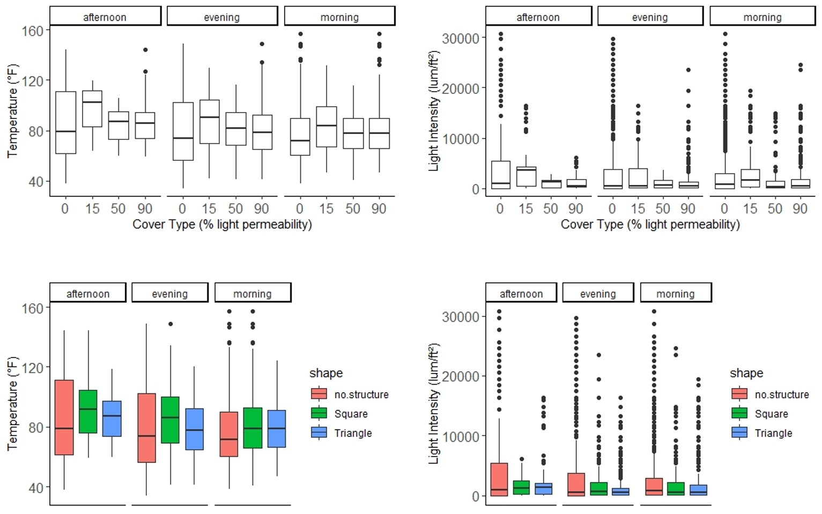

**Figure 2. Box plot showing the relationship between temperature (ºF) and the different blockage intensities and shape for the three time blocks. These relationships are also shown for light intensity (lum/ft2). Solid middle lines shows the median of the data, whilst whiskers show 1.5 standard deviation. Solid dots are outliers >1.5 interquartile range (IQR).**

**Discussion**

In this study we aimed to construct shelters that are easily assembled in the field and are more cost-effective than other prototypes already discussed in published literature. We wished to explore the efficiency of these shelters at cooling canopy temperature and blocking the incoming sunlight. By using PVC piping and shade cloths, we were able design and build cost-effective shelters that were easily assembled and disassembled in the field. This is beneficial because it means that shelters can be easily transported between locations and can be set-up almost anywhere. It also allows for the opportunity to run shelter experiments at a grand scale, something otherwise not feasible if funding is limited.

We compared light intensity and temperature and concluded that the two are positively correlated. To ensure that this was the case under all condition, we further subdivided the data into time blocks for the various blockage intensities and determined that the above relationship remained true regardless. This is because sunlight carries solar energetic particles whose energy is converted into heat upon contact with the earth resulting in an increase in the mean temperature27. Hence, it’s not surprising that with increased solar intensity, the microsite temperature generally increased as well.

The open microsites showed the most variation in data compared to two other structures for both temperature and light intensity (Figure 2), specifically during the afternoon and evening time slots. Furthermore, the open also showed the most variation compared to the other blockage intensities, except during the morning when the 15% cover type experienced the most variation. This demonstrates that although there may be specific times during the day when no shelter may be better than any shelter, the open simply does not offer the same consistency of refuge from extreme environmental conditions as shelter does. The spatial and temporal patterns of thermal heterogeneity are able to create unique selective pressures in different environments28. Shaded microhabitats, such as those created by vegetation, are vital components that increase thermal heterogeneity of the landscape for a variety of animals such as ectotherm, in addition to providing refuge29,30. Our data supports the hypothesis that shelters too can act as canopies that increase thermal heterogeneity within a given environment.

Post-hoc analyses demonstrated that triangular shelters at 90% blockage intensity not only blocked sunlight most successfully, but also resulted in the most cooling effect (Table 2 and 3). This was contrary to earlier predictions about temperature stagnation as a result of limited wind flow. This is likely because of holes that appeared on cloths, which enabled uniform wind flow through and out the shelters. Interestingly, these holes act similar to branches on natural vegetation that create a non-uniform shading patterns under canopy. These irregularities may result in a complex mosaic of thermal and radiative properties that may be beneficial, though need to be further explored31.

Signs of human-induced climate change is already visible in a variety of ecosystems. Species all around the world face changes in distribution and abundance due to migration and range shift32. This change with impact the physiology, growth, and productivity of biota33, as well as their behaviour34. Given the current rates, it will not be long before species can no longer physiologically and behaviourally mitigate the impacts of climate change. Animals such as lizards may already be over-expending energy when trying to thermoregulate35. Thus, the importance of shelter as a climate refuge is now more crucial than ever.

In California, climate change is further interfering with wildfire regimes and altering biological communities36. Not only can post-disturbance recovery be slow20 competition and invasion by non-natives is amongst other problems slowing the recruitment of native vegetation37,38. A clear implication is therefore the benefits of shelters as a mode of conservation post-disturbance whilst other efforts are made to re-establish the native community.

We suggest that future studies experiment with different dimensions and more shapes and explore their impacts on canopy temperature and light intensity, alongside measuring other climatic parameters such as relative humidity. Directionality of shelter opening should also be explored. Additionally, camera trapping at each shelter-open microsite may useful to determine whether shelters are actually used by animals, and if yes, which species. We hope our study has provided some direction for future mitigation efforts that may be key towards management of habitats and species at risk of extinction due to climate change and land-use.

**Funding**

This research was made possible through a Natural Sciences and Engineering Research Council of Canada (NSERC) grant awarded to CJL and the Mitacs Globalink award, alongside York University Faculty of Graduate Studies (FGS) award granted to NG and MZ.

**Acknowledgements**

We are thankful to BLM for allowing us to conduct research in their land. We are grateful to M. MacDonald for her help in designing the project and editing the manuscript. We also thank J. Braun, M. Owen, and S. Haas for their feedback on statistical analyses.

**Literature Cited**

1. Abatzoglou, J. T. & Kolden, C. A. Climate Change in Western US Deserts: Potential for Increased Wildfire and Invasive Annual Grasses. *Rangel. Ecol. Manag.* **64**, 471–478 (2011).

2. Urban, M. C. Accelerating extinction risk from climate change. *Science* **348**, 571–573 (2015).

3. Nopper, J., Riemann, J. C., Brinkmann, K., Rödel, M.-O. & Ganzhorn, J. U. Differences in land cover – biodiversity relationships complicate the assignment of conservation values in human-used landscapes. *Ecol. Indic.* **90**, 112–119 (2018).

4. Irwin, M. T. *et al.* Patterns of species change in anthropogenically disturbed forests of Madagascar. *Biol. Conserv.* **143**, 2351–2362 (2010).

5. *Urbanization, biodiversity and ecosystem services: challenges and opportunities: a global assessment ; a part of the cities and biodiversity outlook project*. (Springer, 2013).

6. Titus, J. H., Nowak, R. S. & Smith, S. D. Soil resource heterogeneity in the Mojave Desert. *J. Arid Environ.* **52**, 269–292 (2002).

7. Pianka, E. R. Convexity, Desert Lizards, and Spatial Heterogeneity. *Ecology* **47**, 1055–1059 (1966).

8. Thiele, T., Jeltsch, F. & Blaum, N. Importance of woody vegetation for foraging site selection in the Southern Pied Babbler (Turdoides bicolor) under two different land use regimes. *J. Arid Environ.* **72**, 471–482 (2008).

9. Thyen, S. & Exo, K.-M. Interactive effects of time and vegetation on reproduction of redshanks (Tringa totanus) breeding in Wadden Sea salt marshes. *J. Ornithol.* **146**, 215–225 (2005).

10. *Ecology of predator-prey interactions*. (Oxford University Press, 2005).

11. Parmenter, R. R. & MacMahon, J. A. Factors determining the abundance and distribution of rodents in a shrub-steppe ecosystem: the role of shrubs. *Oecologia* **59**, 145–156 (1983).

12. Stuart, J. D. & Sawyer, J. O. *Trees and shrubs of California*. (University of California Press, 2001).

13. Filazzola, A. & Lortie, C. J. A systematic review and conceptual framework for the mechanistic pathways of nurse plants: A systematic review of nurse-plant mechanisms. *Glob. Ecol. Biogeogr.* **23**, 1335–1345 (2014).

14. Filazzola, A. *et al.* Non-trophic interactions in deserts: Facilitation, interference, and an endangered lizard species. *Basic Appl. Ecol.* **20**, 51–61 (2017).

15. Holzapfel, C. & Mahall, B. E. Bidirectional facilitation and interference between shrubs and annuals in the Mojave Desert. *Ecology* **80**, 1747–1761 (1999).

16. Lortie, C. J., Filazzola, A. & Sotomayor, D. A. Functional assessment of animal interactions with shrub-facilitation complexes: a formal synthesis and conceptual framework. *Funct. Ecol.* **30**, 41–51 (2016).

17. Westphal, M. F., Noble, T., Butterfield, H. S. & Lortie, C. J. A test of desert shrub facilitation via radiotelemetric monitoring of a diurnal lizard. *Ecol. Evol.* **8**, 12153–12162 (2018).

18. Eliason, S. A. & Allen, E. B. Exotic Grass Competition in Suppressing Native Shrubland Re-establishment. *Restor. Ecol.* **5**, 245–255 (1997).

19. Germano, D. J. *et al.* The San Joaquin Desert of California: Ecologically Misunderstood and Overlooked. *Nat. Areas J.* **31**, 138–147 (2011).

20. Berry, K. H., Weigand, J. F., Gowan, T. A. & Mack, J. S. Bidirectional recovery patterns of Mojave Desert vegetation in an aqueduct pipeline corridor after 36 years: I. Perennial shrubs and grasses. *J. Arid Environ.* **124**, 413–425 (2016).

21. Yahdjian, L. & Sala, O. E. A rainout shelter design for intercepting different amounts of rainfall. *Oecologia* **133**, 95–101 (2002).

22. Hollister, R. D. & Webber, P. J. Biotic validation of small open-top chambers in a tundra ecosystem. *Glob. Change Biol.* **6**, 835–842 (2000).

23. Harrison, S. & Cruickshank, C. A. A review of strategies for the control of high temperature stagnation in solar collectors and systems. *Energy Procedia* **30**, 793–804 (2012).

24. R Core Team. *R*. (2019).

25. Wickham, H. *Ggplot2: elegant graphics for data analysis*. (Springer, 2009).

26. Lenth, R. & Herve, M. *Emmeans, Estimated Marginal Means, aka Least-Squared Means.* (2019).

27. Haigh, J. D. The Sun and the Earth’s Climate. *Living Rev. Sol. Phys.* **4**, (2007).

28. Angilletta Jr., M. J. *Thermal Adaptation*. (Oxford University Press, 2009).

29. Diaz, J. A. & Cabezas-Diaz, S. Seasonal variation in the contribution of different behavioural mechanisms to lizard thermoregulation. *Funct. Ecol.* **18**, 867–875 (2004).

30. Bauwens, D., Hertz, P. E. & Castilla, A. M. Thermoregulation in a Lacertid Lizard: The Relative Contributions of Distinct Behavioral Mechanisms. *Ecology* **77**, 1818–1830 (1996).

31. Ivey, K. N., Cornwall, M., Crowell, H., Ghazian, N., Owen, M., Nix, E., Zuliani, M., Lortie, C.J., Westphal, M., & Taylor, M*.* Thermal Ecology of the Federally Endangered Blunt-nosed Leaopard Lizard (Gambelia sila). *Manuscript Submitted for Publication* (2019).

32. Midgley, G. F., Hannah, L., Millar, D., Rutherford, M. C. & Powrie, L. W. Assessing the vulnerability of species richness to anthropogenic climate change in a biodiversity hotspot. *Glob. Ecol. Biogeogr.* **11**, 445–451 (2002).

33. Cannell, M. UK conifer forests may be growing faster in response to increased N deposition, atmospheric CO2 and temperature. *Forestry* **71**, 277–296 (1998).

34. *‘Fingerprints’ of climate change: adapted behaviour and shifting species ranges*. (Kluwer Academic/Plenum Publishers, 2001).

35. Vickers, M., Manicom, C. & Schwarzkopf, L. Extending the Cost-Benefit Model of Thermoregulation: High-Temperature Environments. *Am. Nat.* **177**, 452–461 (2011).

36. Bishop, T. B. B., Gill, R. A., McMillan, B. R. & St. Clair, S. B. Fire, rodent herbivory, and plant competition: implications for invasion and altered fire regimes in the Mojave Desert. *Oecologia* (2019).

37. Bowman, D. M. J. S. *et al.* Fire in the Earth System. *Science* **324**, 481–484 (2009).

38. Bowman, D. M. J. S. *et al.* The human dimension of fire regimes on Earth: The human dimension of fire regimes on Earth. *J. Biogeogr.* **38**, 2223–2236 (2011).

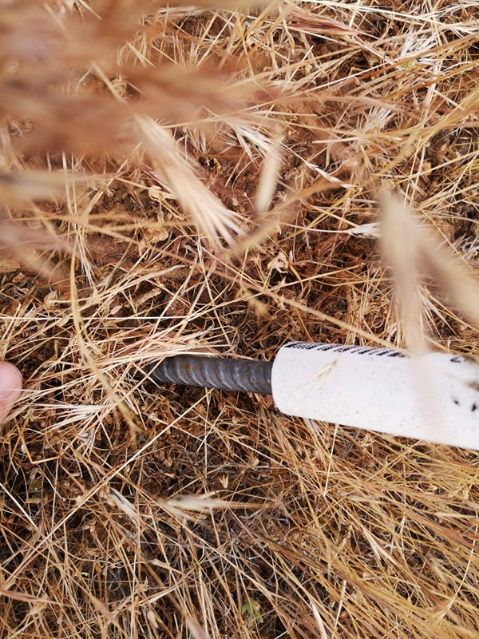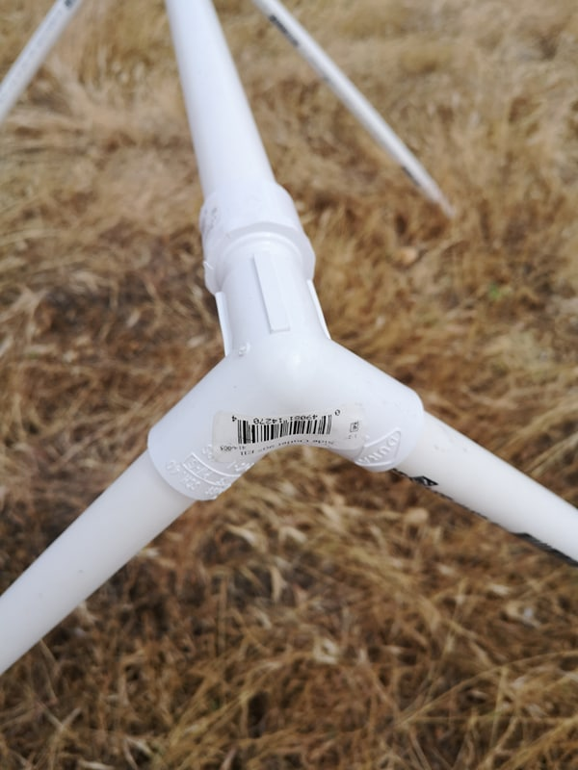**Supplementary Appendix**

**Figure 1. Left- General PVC triangular structure and joint. Right-Metal stake and with PVC pipe slid on.**

**Figure 1. Scatterplot showing the relationship between light intensity (lum/ft2) and temperature (ºF). Blue line represents smooth conditional mean (Kendall’s tau=0.488, z=76.173, p<2.2e-16).**

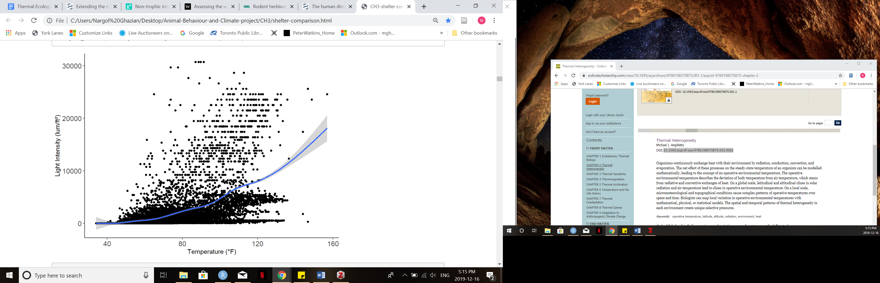

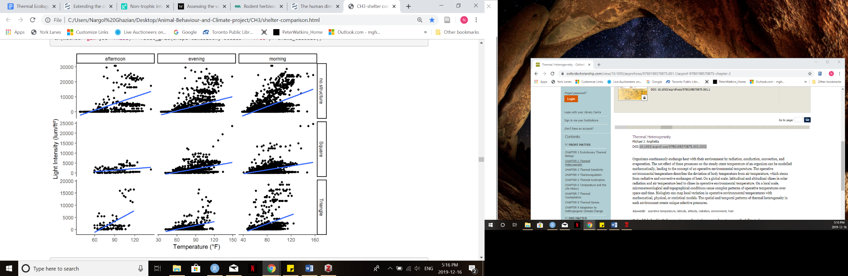**Figure 2. Scatterplot showing the relationship between light intensity (lum/ft2) and temperature (ºF) for different cover types (left) and structures (right) at different times of the day. Blue line represents smooth conditional mean.**

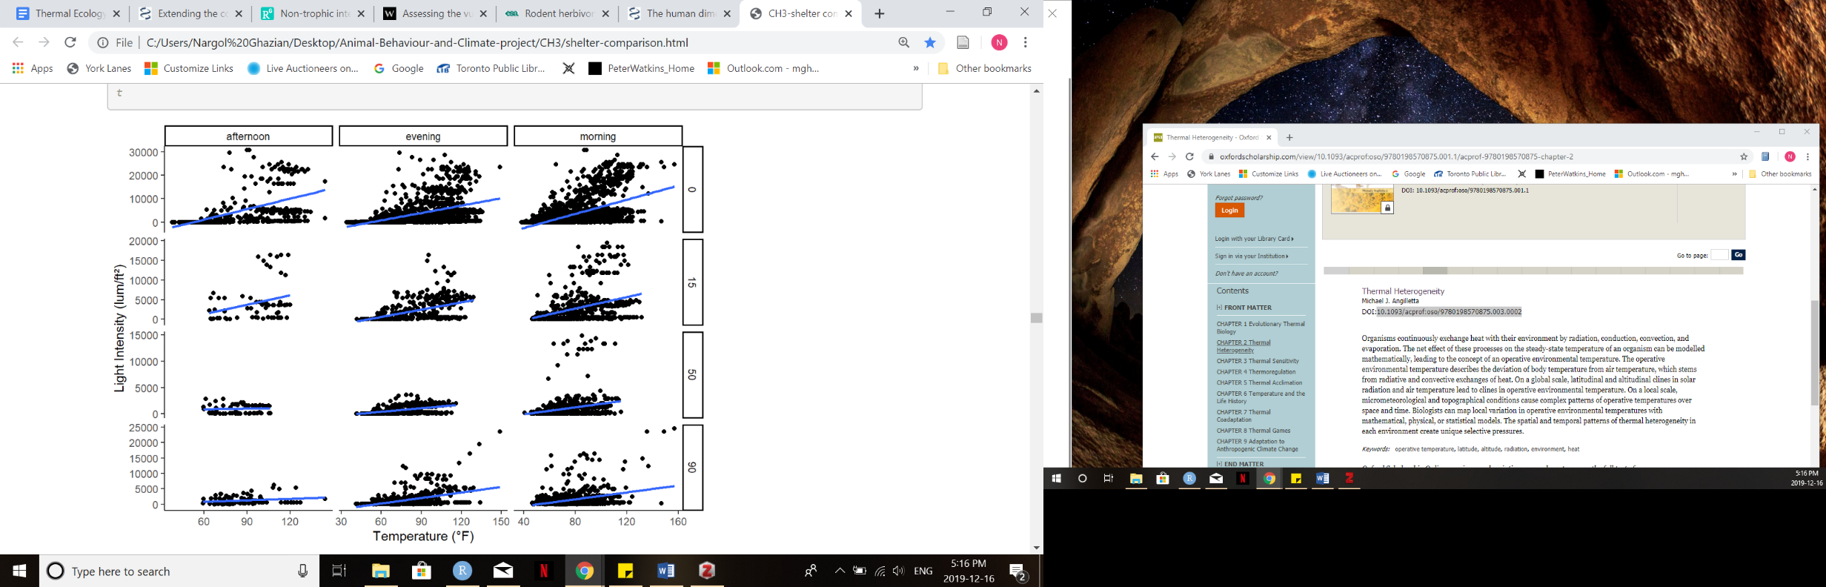

**Table 1. Location (latitude and longitude coordinates) of each shelter-open microsite is given, alongside its shape and cover type.**

|  |  |  |  |  |
| --- | --- | --- | --- | --- |
| **Shelter ID** | **Latitude** | **Longitude** | **Shape (Triangle/Square)** | **Cover type** |
| 1 | 36.69363 | -120.79318 | T | 15% |
| 2 | 36.69364 | -120.79331 | S | 15% |
| 3 | 36.69355 | -120.79315 | S | 90% |
| 4 | 36.69349 | -120.79320 | T | 90% |
| 5 | 36.69349 | -120.79311 | T | 50% |
| 6 | 36.39342 | -120.79311 | S | 50% |
| 7 | 36.69394 | -120.79300 | S | 15% |
| 8 | 36.69397 | -120.79292 | T | 15% |
| 9 | 36.69401 | -120.79282 | S | 90% |
| 10 | 36.694 | -120.79295 | T | 90% |
| 11 | 36.69405 | -120.79305 | S | 50% |
| 12 | 36.69408 | -120.79301 | T | 50% |